Ballet & Jazz Classes

*JM DANCE CENTER is proud to present Ballet and Jazz classes. Our curriculum includes introductory Ballet classes, which are vital to the training of young dancers in the basics of creative and expressive dance, and continues into more advanced, fast paced, and modern dance styles.*

*Our classes encourage imagination, musicality, improvisation, and graceful movement. Your children will practice the basic stretches and dance moves, while*

*learning proper class etiquette and discipline.*

*For more information, call us at* ***786.226.7202*** *or email us at* [***jmdancecenter@gmail.com.***](mailto:jmdancecenter@gmail.com)

Visit us at [**www.jmdancemiami.com**](http://www.jmdancemiami.com)

**You can make your payments through our website, this service has a convenience fee of $2.50, or enroll for schedule automated payments, this service is free of charge**.

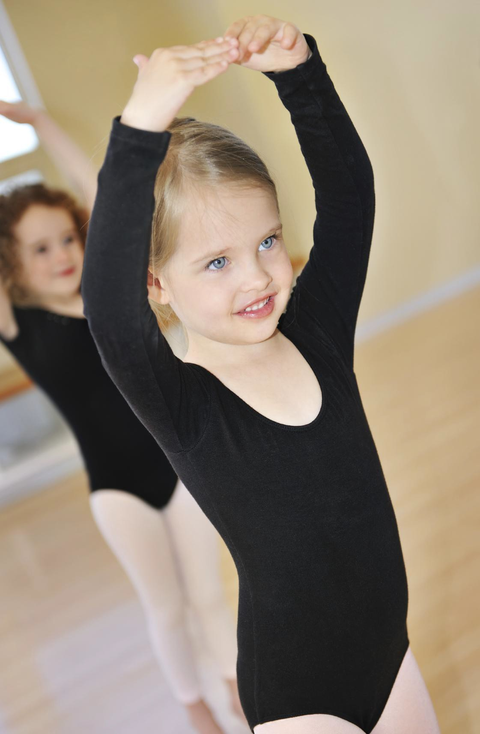

Price

$80.00 PER MONTH

2 classes x week

www.jmdancemiami.com

